APPLICATION BASED QUESTIONS

Name: ADHITHYA.S
Register Number: 192412352
Course Code: ITA0606
Course Name: MACHINE LEARNING

11. Bayes' Theorem — Adulterated Oil Bottle

Given
Shop | Pure oil | Adulterated oil | Total
Shop X | 20 | 30 | 50
Shop Y | 40 | 20 | 60

- Shop Y is twice as likely to be chosen as Shop X ⇒ P(X) = 1/3, P(Y) = 2/3.
- P(Adulterated | X) = 30/50 = 3/5 = 0.60
- P(Adulterated | Y) = 20/60 = 1/3 = 0.3333

Step 1: Total Probability of an Adulterated Bottle
P(A) = P(X)·P(A|X) + P(Y)·P(A|Y) = (1/3)(0.60) + (2/3)(0.3333)
P(A) = 0.20 + 0.2222 = 0.4222 (= 19/45)

Step 2: Apply Bayes' Theorem
P(X | A) = [P(X)·P(A|X)] / P(A) = 0.20 / 0.4222 = 0.4737 (= 9/19)
P(Y | A) = [P(Y)·P(A|Y)] / P(A) = 0.2222 / 0.4222 = 0.5263 (= 10/19)

Conclusion
- Probability the adulterated bottle came from Shop X ≈ 47.37%.
- Probability the adulterated bottle came from Shop Y ≈ 52.63%.
- Check: 0.4737 + 0.5263 = 1.00 ✓ — even though Shop Y is chosen twice as often, its lower adulteration rate makes the two posterior probabilities much closer than the prior probabilities.

12. Bayes' Theorem — Defective Warehouse Item

Given
Section | Defective | Non-defective | Total
Section A | 15 | 35 | 50
Section B | 25 | 25 | 50

- Section A is three times as likely to be chosen as Section B ⇒ P(A) = 3/4 = 0.75, P(B) = 1/4 = 0.25.
- P(Defective | A) = 15/50 = 0.30
- P(Defective | B) = 25/50 = 0.50

Step 1: Total Probability of a Defective Item
P(D) = P(A)·P(D|A) + P(B)·P(D|B) = (0.75)(0.30) + (0.25)(0.50)
P(D) = 0.225 + 0.125 = 0.35

Step 2: Apply Bayes' Theorem
P(A | D) = [P(A)·P(D|A)] / P(D) = 0.225 / 0.35 = 0.6429 (= 9/14)
P(B | D) = [P(B)·P(D|B)] / P(D) = 0.125 / 0.35 = 0.3571 (= 5/14)

Conclusion
- Probability the defective item came from Section A ≈ 64.29%.
- Probability the defective item came from Section B ≈ 35.71%.
- Even though Section B has a higher defect rate (50% vs 30%), Section A is still the more likely source because it is chosen three times as often — the strong prior outweighs the higher likelihood from B.

13. Classification Metrics — KNN Model (Dataset A)

Setting Up the Confusion Matrix
- Samples per class = 1000; test split = 20% ⇒ test samples per class = 200; total test set = 400.
- TP = 120 ⇒ out of 200 actual positives, 120 correctly predicted positive ⇒ FN = 200 − 120 = 80.
- TN = 150 ⇒ out of 200 actual negatives, 150 correctly predicted negative ⇒ FP = 200 − 150 = 50.
- Check: TP + TN + FP + FN = 120 + 150 + 50 + 80 = 400 ✓
 | Predicted Positive | Predicted Negative | Total (Actual)
Actual Positive | TP = 120 | FN = 80 | 200
Actual Negative | FP = 50 | TN = 150 | 200

Calculations
Metric | Formula | Calculation | Result
Accuracy | (TP+TN)/Total | (120+150)/400 | 0.675 = 67.5%
Precision | TP/(TP+FP) | 120/170 | 0.7059 = 70.59%
Sensitivity (Recall) | TP/(TP+FN) | 120/200 | 0.60 = 60%
Specificity | TN/(TN+FP) | 150/200 | 0.75 = 75%

14. Classification Metrics — KNN Model (Medical Imaging, Dataset B)

Setting Up the Confusion Matrix
- Samples per class = 1200; test split = 25% ⇒ test samples per class = 300; total test set = 600.
- TP = 180 ⇒ out of 300 actual positives, 180 correctly predicted positive ⇒ FN = 300 − 180 = 120.
- TN = 160 ⇒ out of 300 actual negatives, 160 correctly predicted negative ⇒ FP = 300 − 160 = 140.
- Check: TP + TN + FP + FN = 180 + 160 + 140 + 120 = 600 ✓
 | Predicted Positive | Predicted Negative | Total (Actual)
Actual Positive | TP = 180 | FN = 120 | 300
Actual Negative | FP = 140 | TN = 160 | 300

Calculations
Metric | Formula | Calculation | Result
Accuracy | (TP+TN)/Total | (180+160)/600 | 0.5667 = 56.67%
Precision | TP/(TP+FP) | 180/320 | 0.5625 = 56.25%
Sensitivity (Recall) | TP/(TP+FN) | 180/300 | 0.60 = 60%
Specificity | TN/(TN+FP) | 160/300 | 0.5333 = 53.33%

Note: this model's overall accuracy (56.67%) is noticeably lower than Dataset A's (67.5%), driven mainly by weaker specificity — the model is more prone to false positives on this dataset.

15. Training vs Validation Loss — Overfitting Analysis

Data
Epoch | Training Loss | Validation Loss
1 | 2.8 | 2.6
2 | 2.4 | 2.2
3 | 2.1 | 1.9
4 | 1.9 | 1.8
5 | 1.7 | 1.9
6 | 1.5 | 2.1
7 | 1.3 | 2.4
8 | 1.2 | 2.7

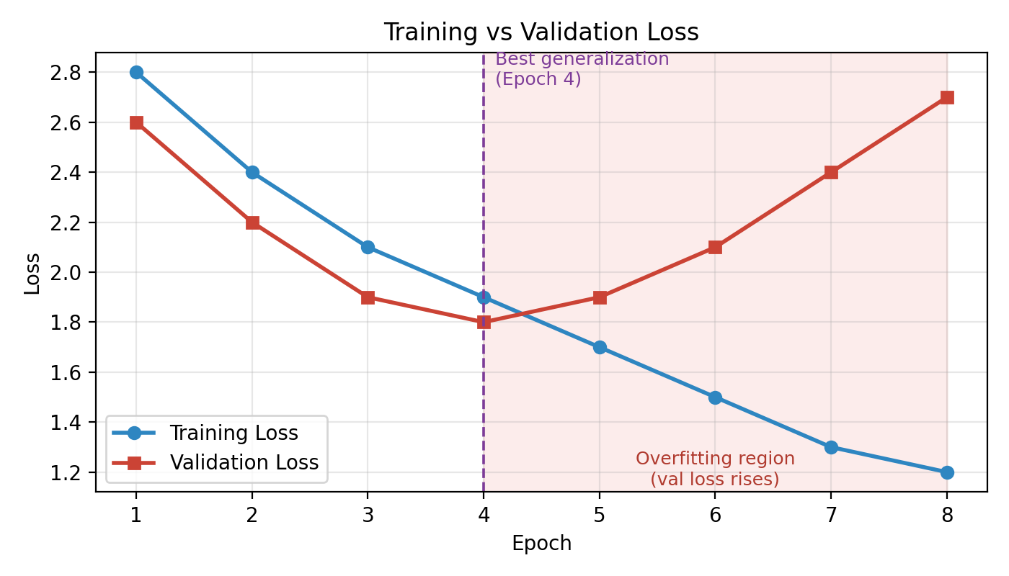

(a) Epoch with Best Generalization Performance
Validation loss decreases from Epoch 1 to Epoch 4 (2.6 → 1.8) and then starts rising from Epoch 5 onward. The lowest validation loss (1.8) occurs at Epoch 4, so the model generalizes best at Epoch 4 — this is the point at which training should ideally be stopped (early stopping).

(b) Where Overfitting Begins
Overfitting begins after Epoch 4 / at Epoch 5. Justification: training loss keeps decreasing continuously through all 8 epochs (1.9 → 1.7 → 1.5 …), showing the model keeps fitting the training data better. But validation loss, which had been falling in step with training loss through Epoch 4, reverses direction and starts increasing from Epoch 5 onward (1.8 → 1.9 → 2.1 → 2.4 → 2.7). This growing gap between a still-falling training loss and a rising validation loss is the classic signature of overfitting: the model is increasingly memorising training-set-specific patterns/noise rather than learning generalizable features.

(c) Techniques to Reduce Overfitting
- Early Stopping: monitor validation loss during training and stop (or restore the best checkpoint) once it stops improving — here, stopping at Epoch 4 would capture the model at its best generalization point instead of continuing to Epoch 8.
- Regularization (L1/L2 weight penalty) or Dropout: adds a penalty on large weights (L1/L2) or randomly deactivates neurons during training (Dropout), which discourages the network from relying too heavily on specific weights/neurons and forces it to learn more robust, generalizable features.
- (Additional options, either may be used in place of the above): Data augmentation to effectively enlarge the training set, or reducing model complexity (fewer layers/parameters) to limit the model's capacity to memorise noise.

